ERD:

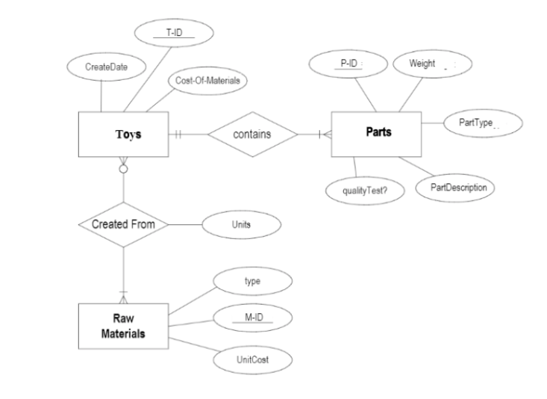

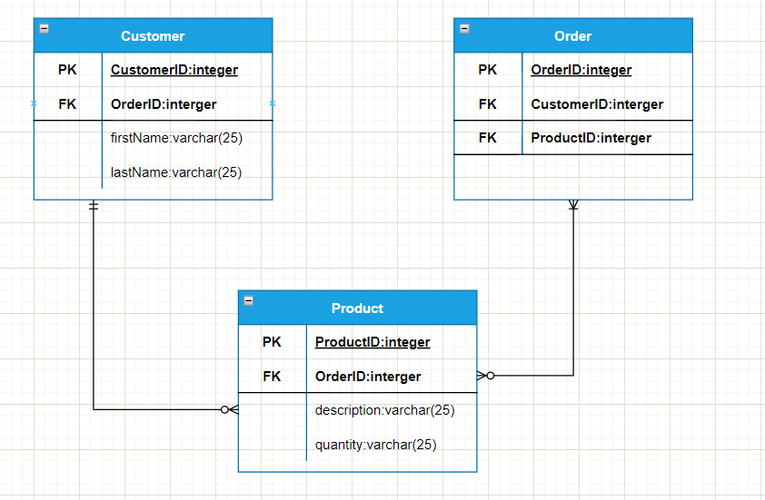

As we see from the above ERD it is clear that it is using the one to many relationships for the process as it clearly demonstrates how the order will be placed from one end to different ends on the request of the employees. It can be 1 to 1 relationship as well until the product availability attribute is known. In order to have the accurate path of the relationship from one to many , many to one and one to one, the above ERD satisfies the criteria and thereby can be easy to form the customer transaction history.